INSTALLATION OF MINIKUBE:(MACOS)

1.Search For minikube installation in any browser and install it: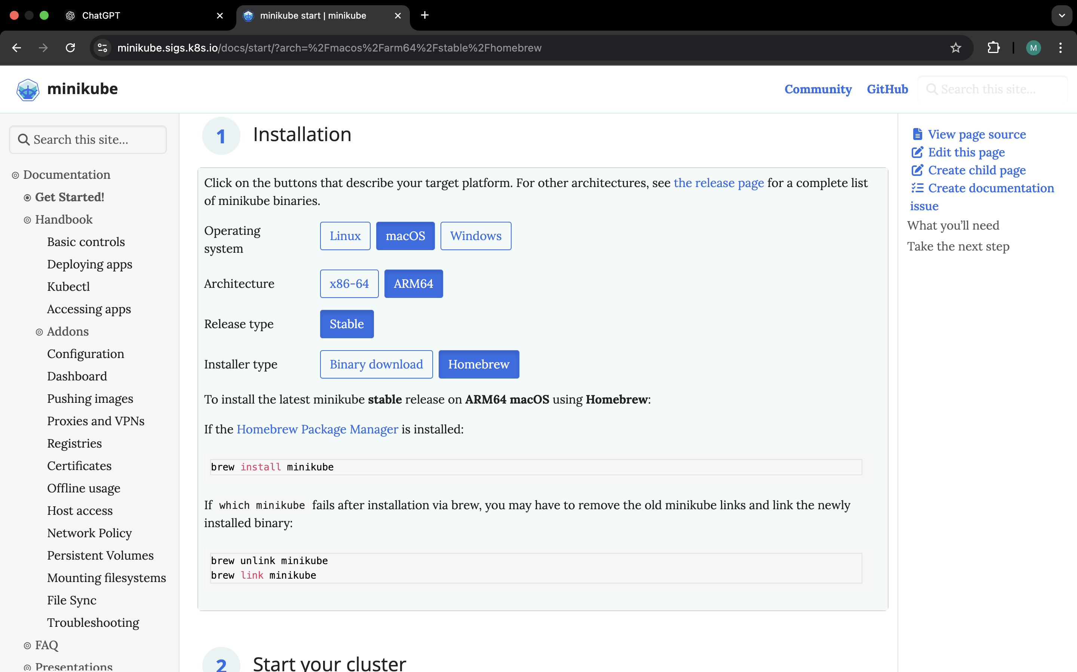

2.Copy the invoke command in the powershell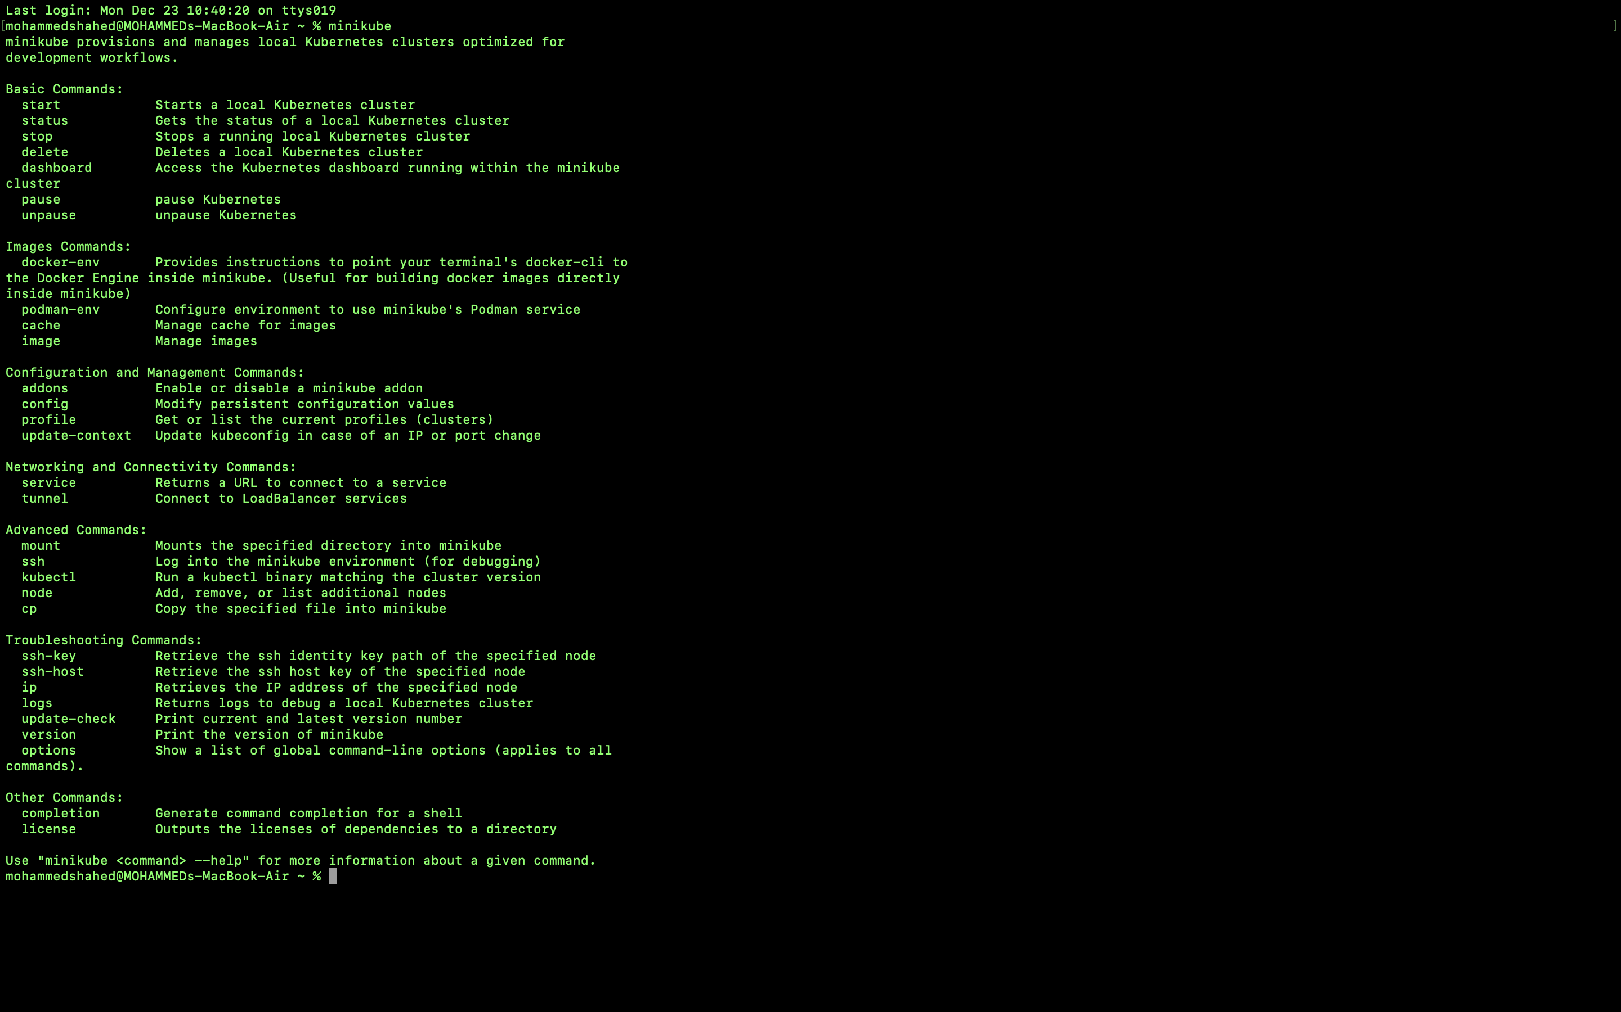

3.Start your minikube by using <minikube start> command: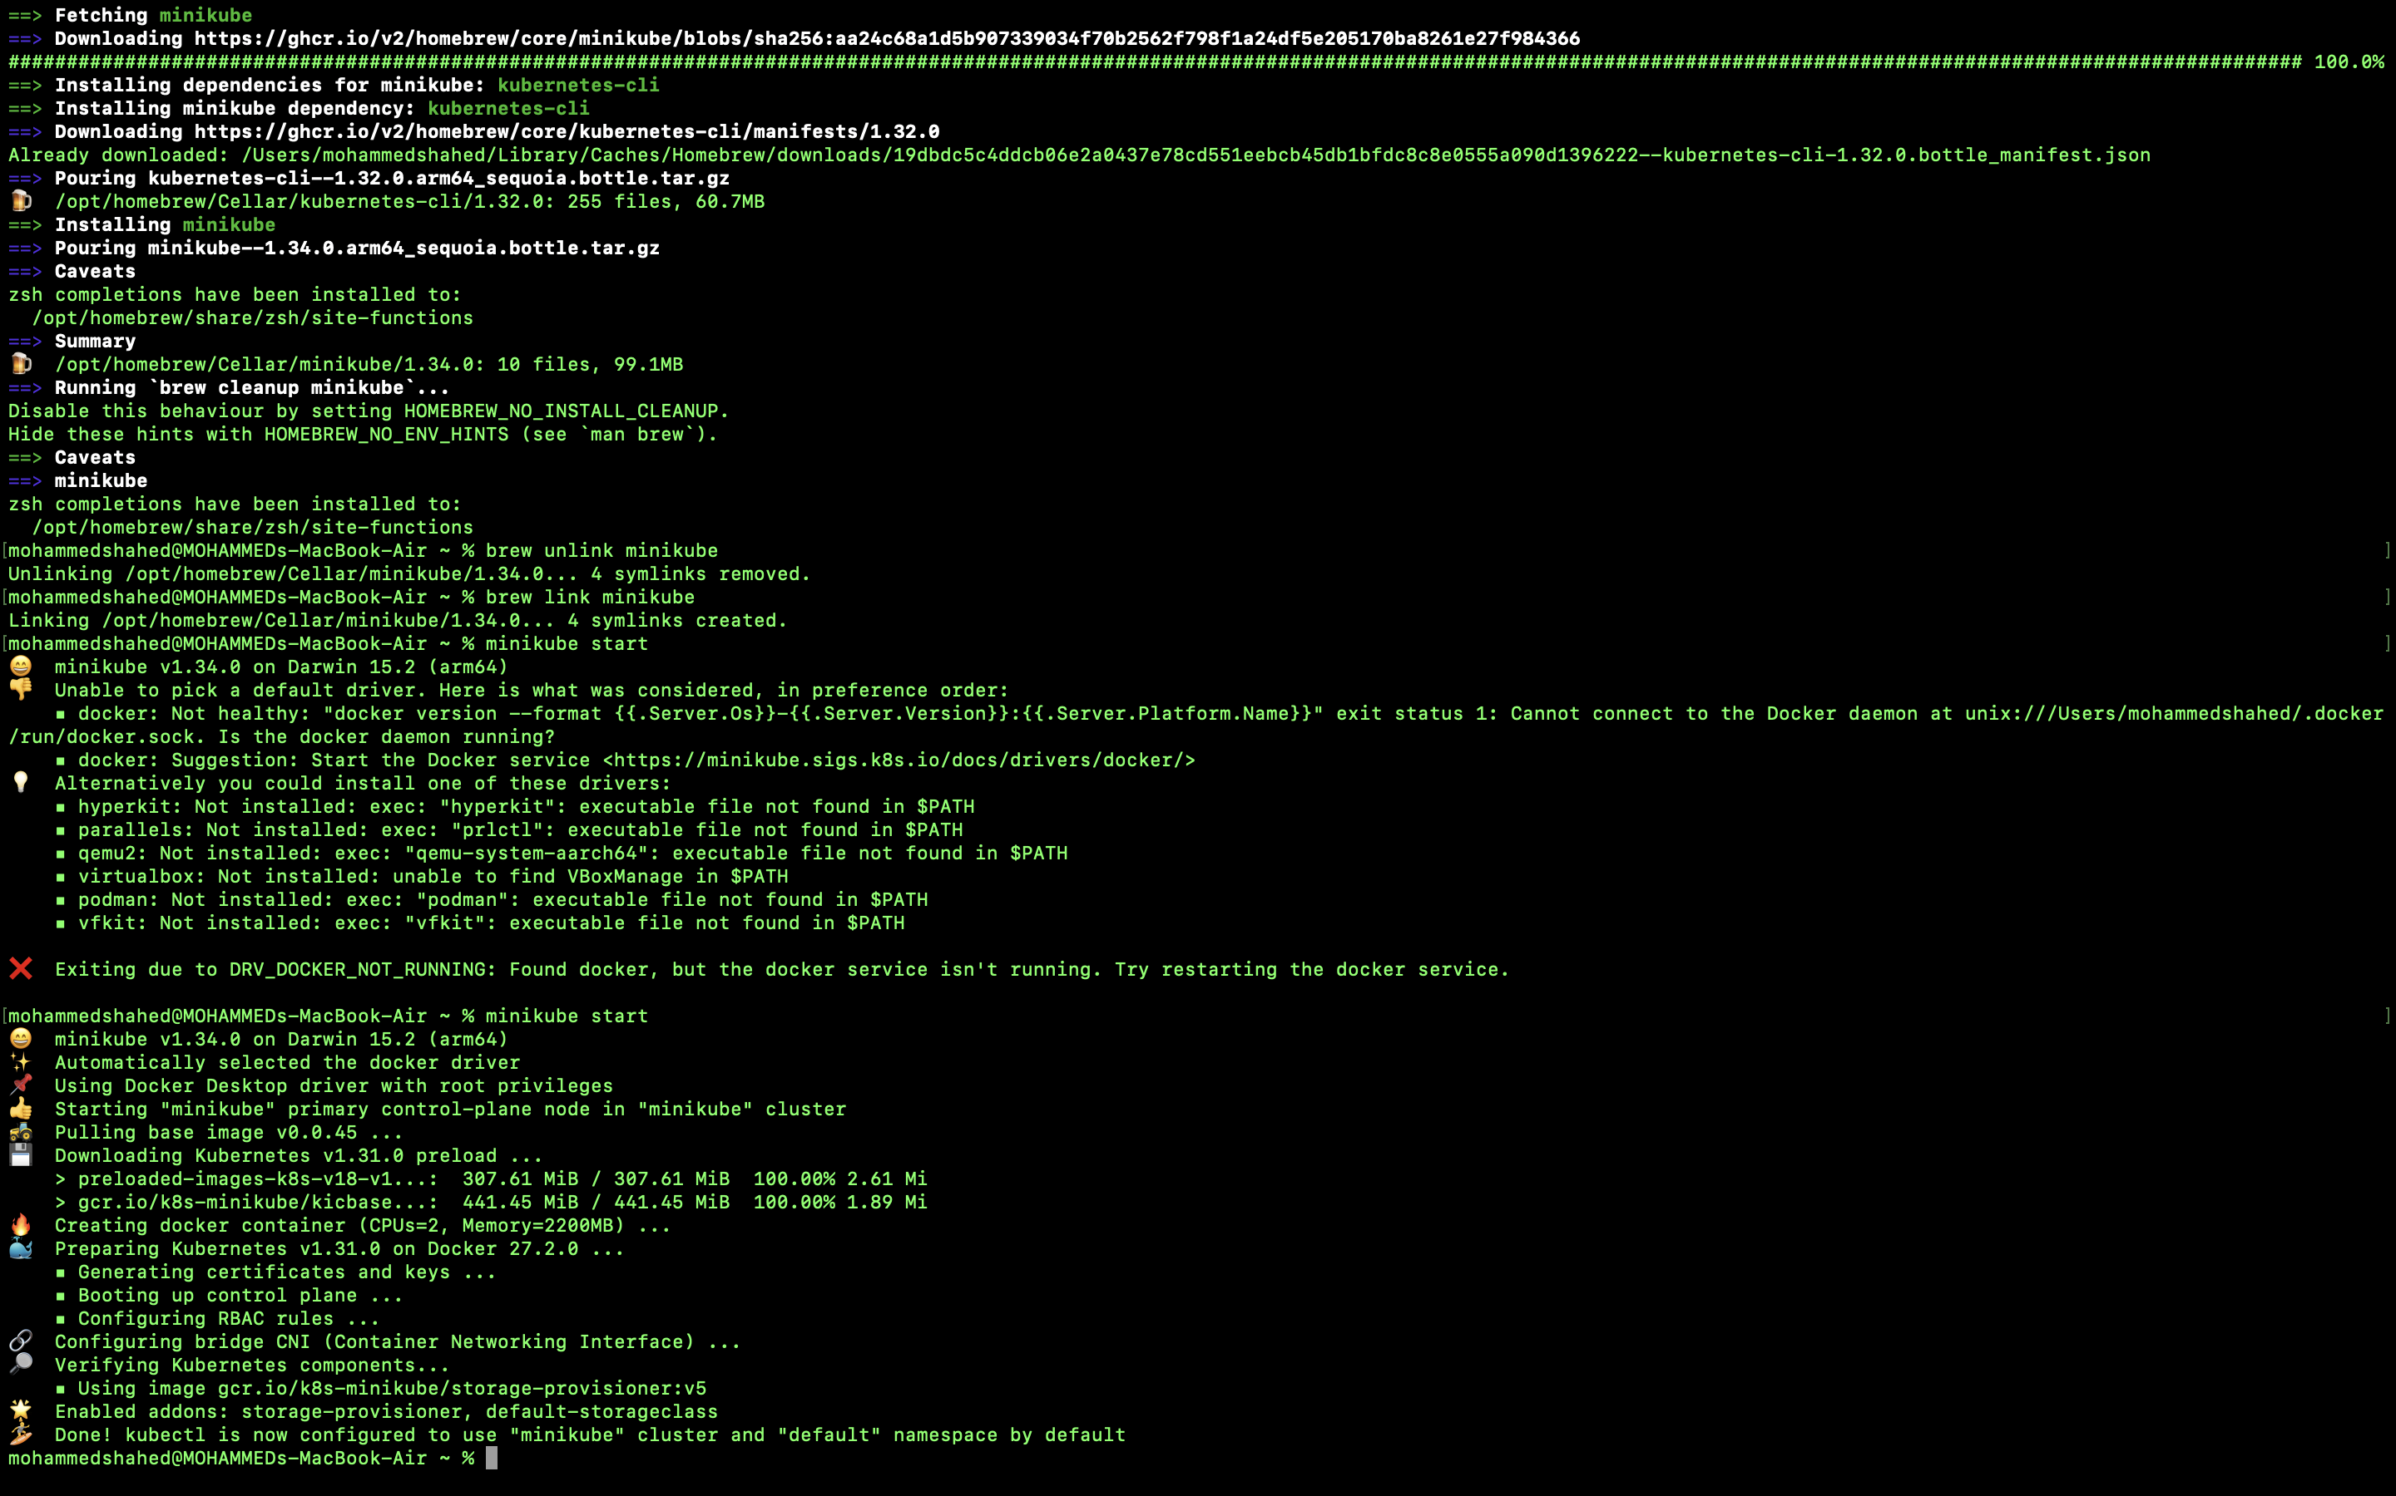

4.minikube start –driver=docker

5.After stoppoing the minikube again you can start and check status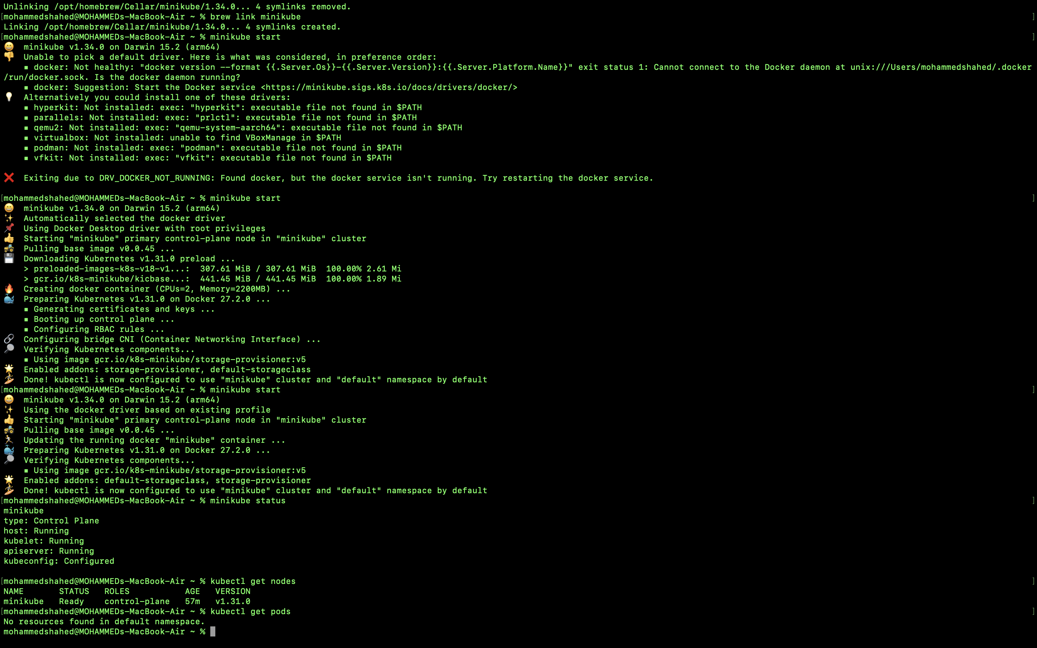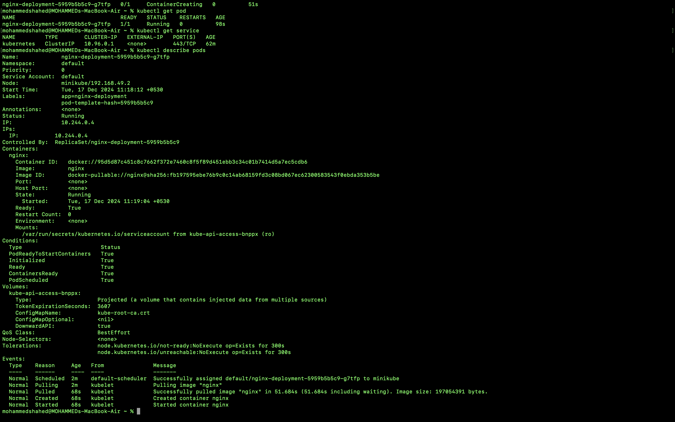

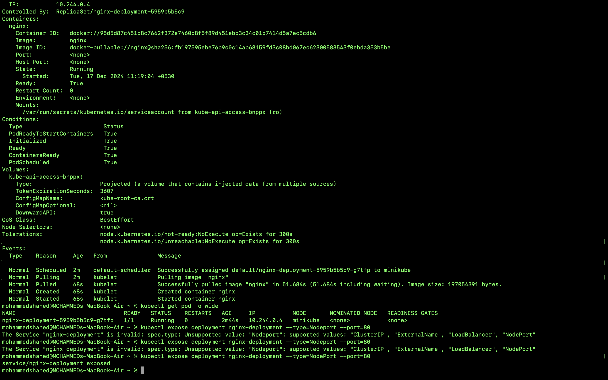

**NAGIOS**

**1.Open docker hub**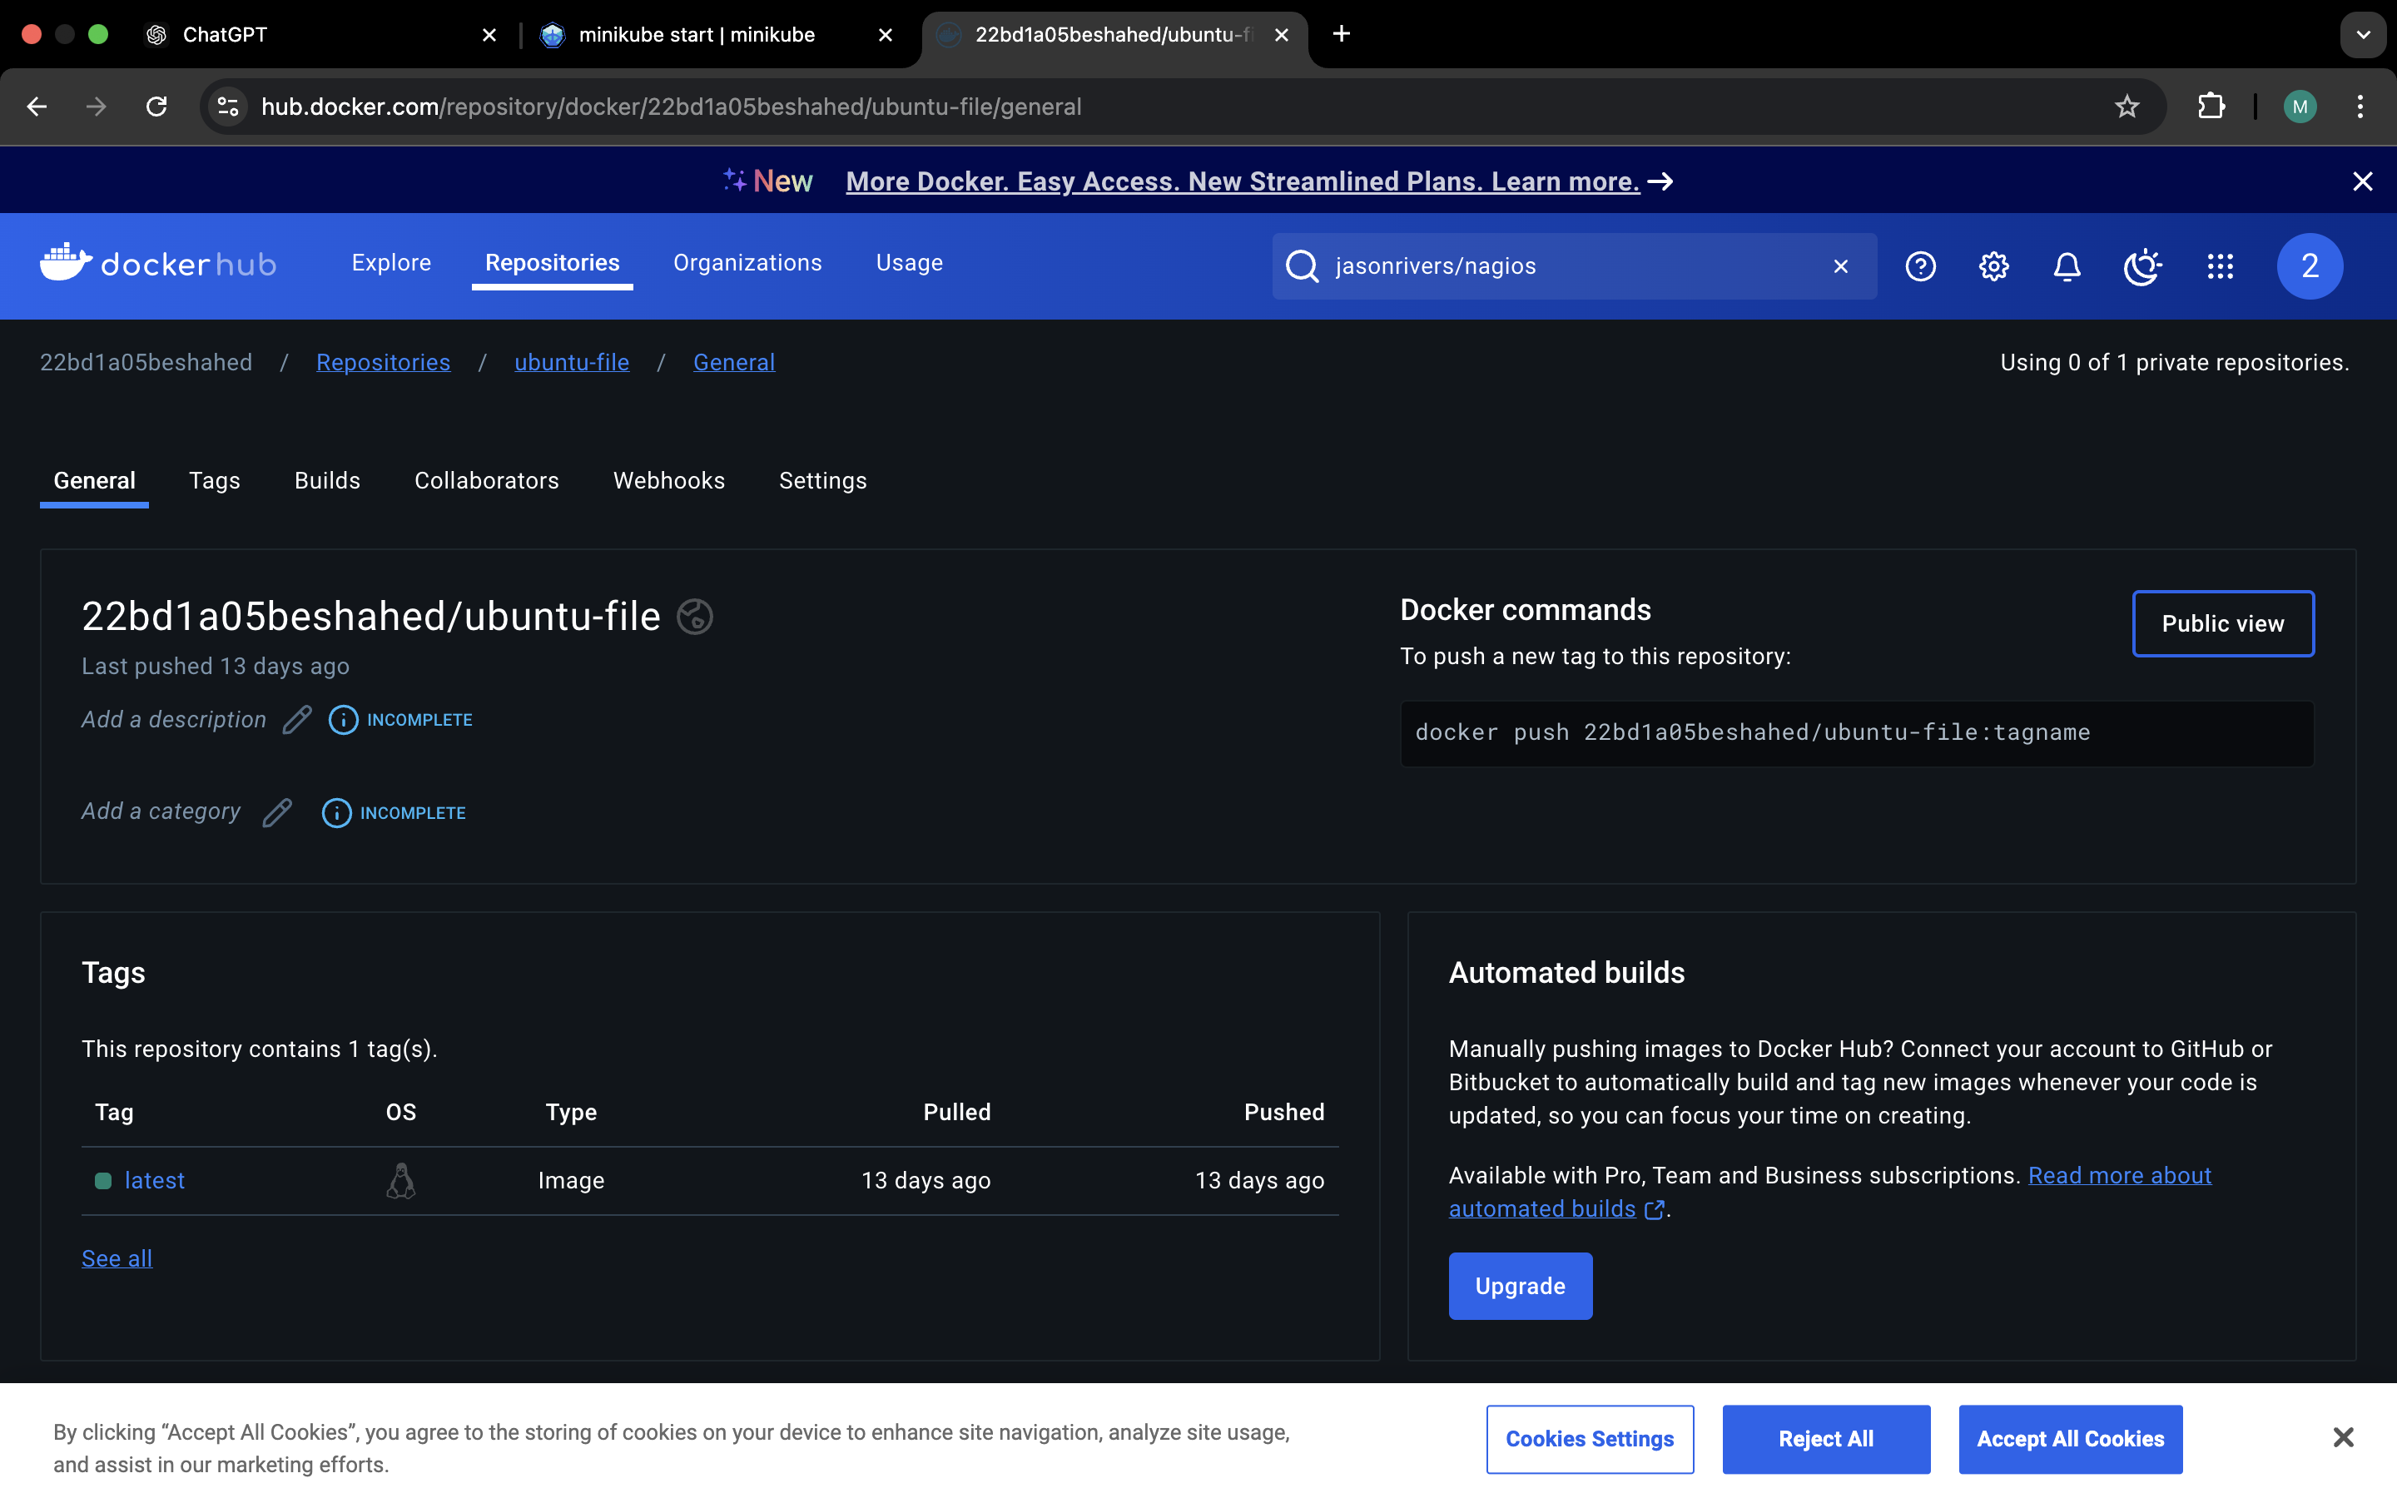

2.In search bar Search for nagios and select jasonrivers/nagios and copy the Docker pull command: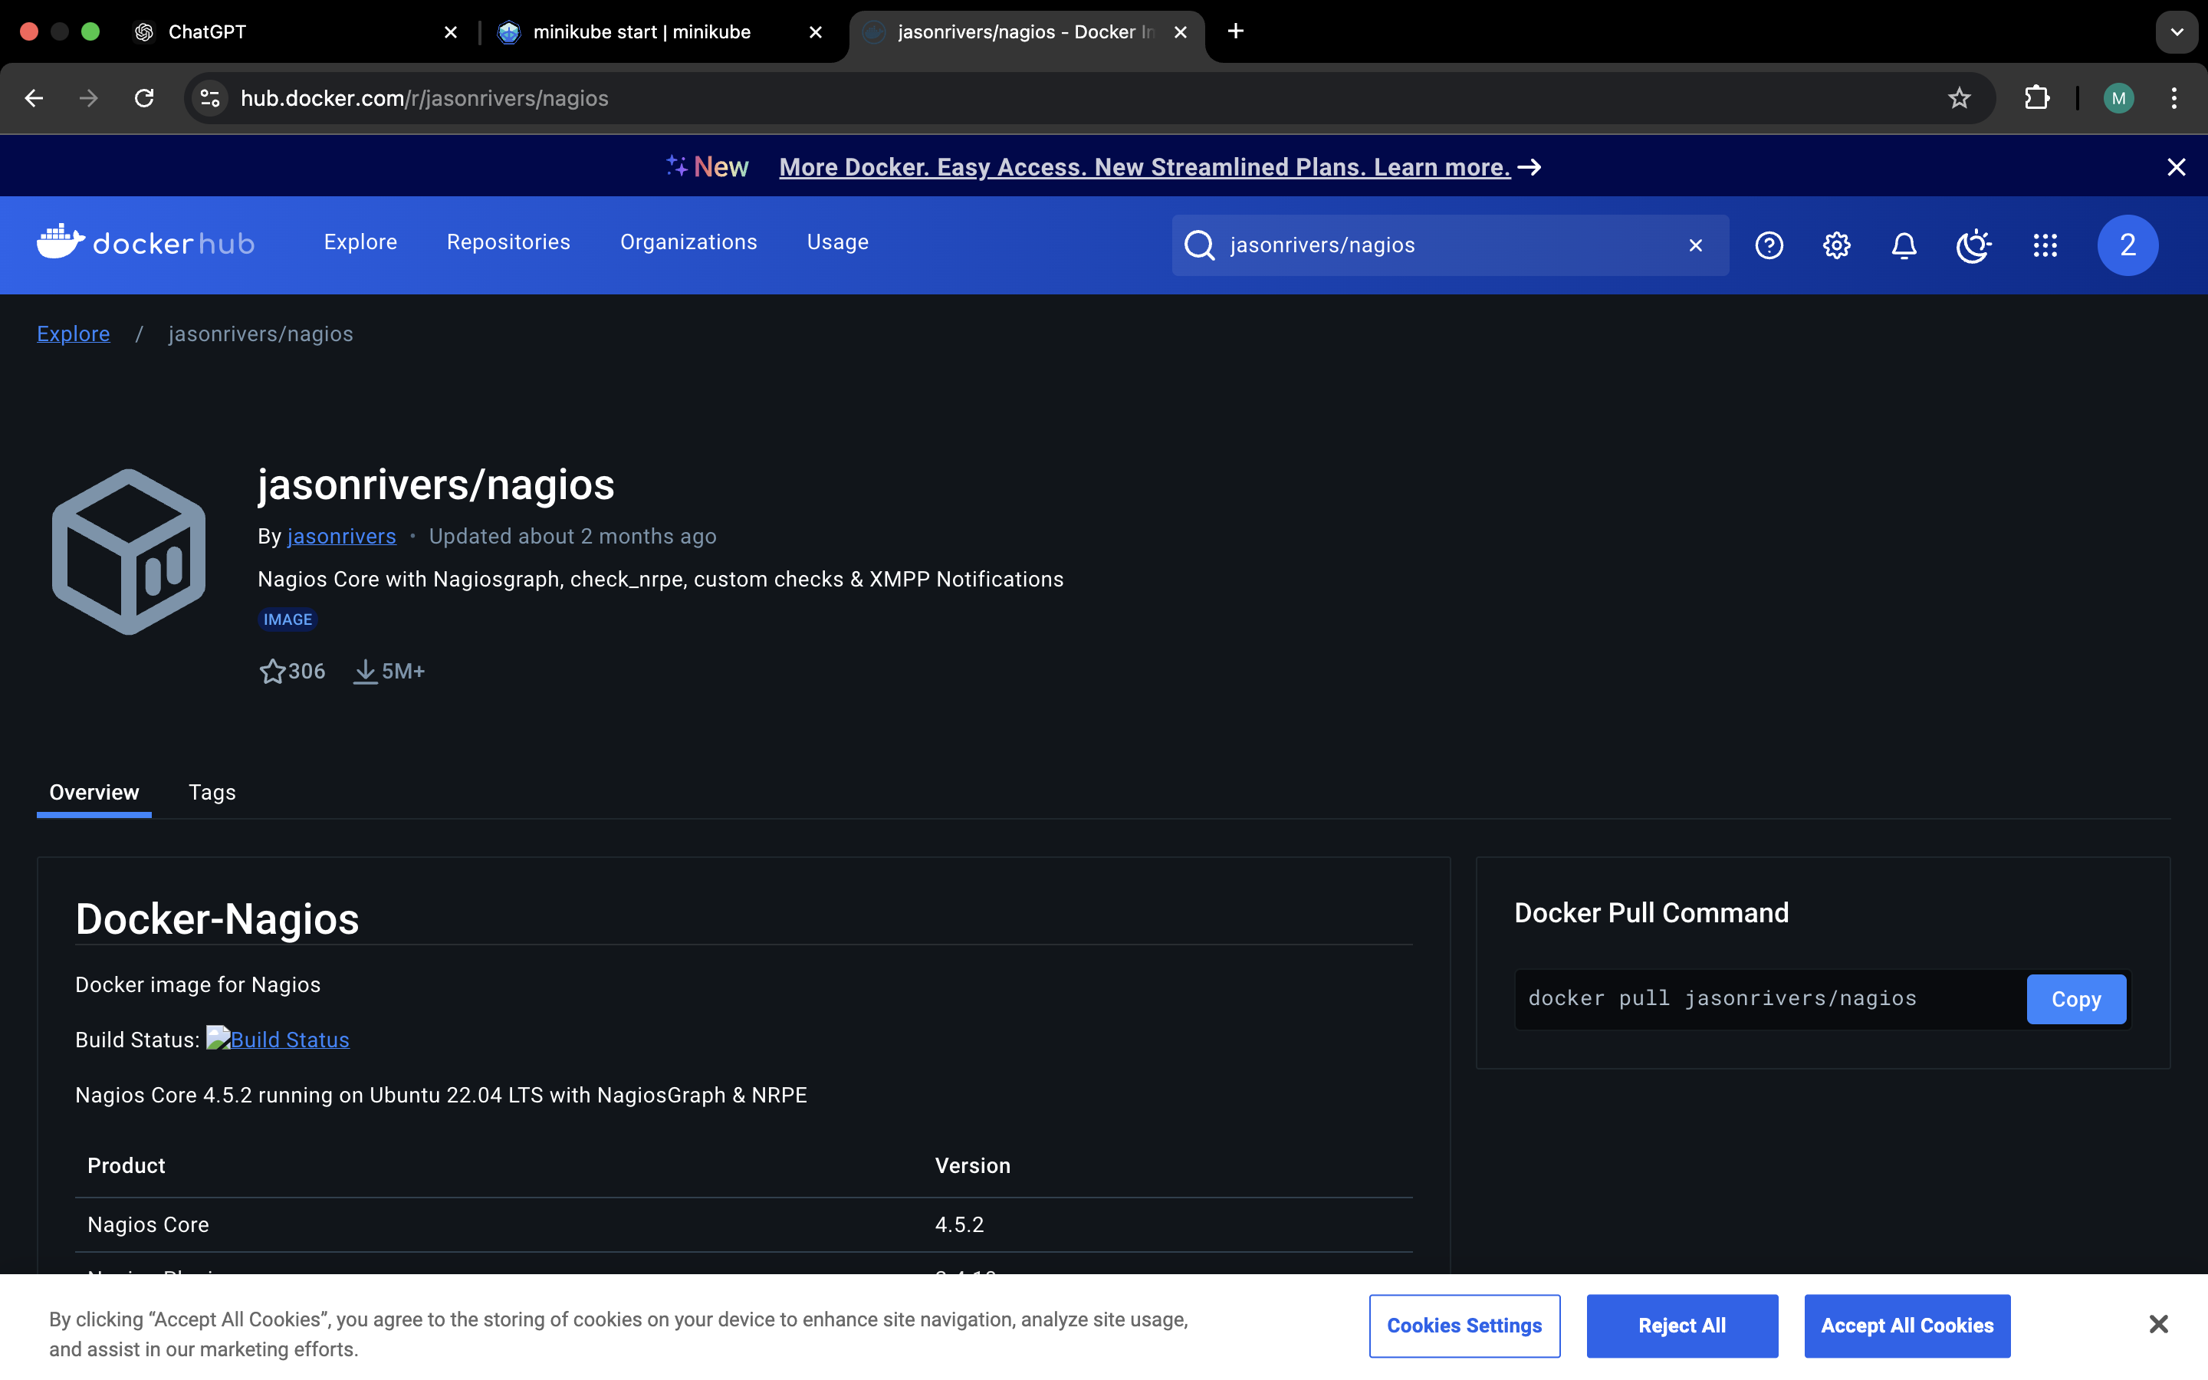

3.Paste the dokcer pull command that you copied :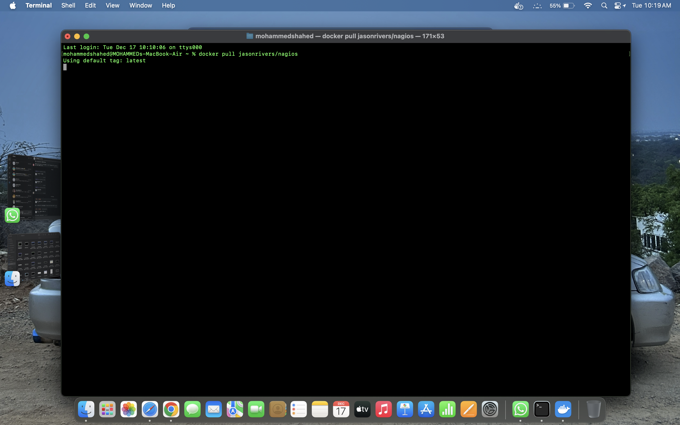

4.Search for docker images in order to check nagios image

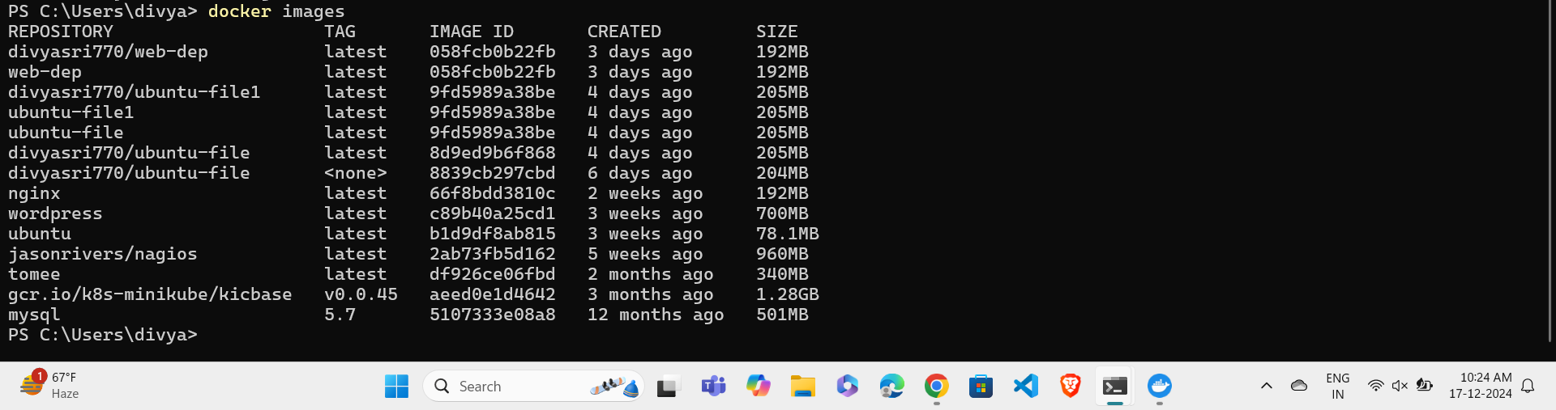

5.Run the nagio image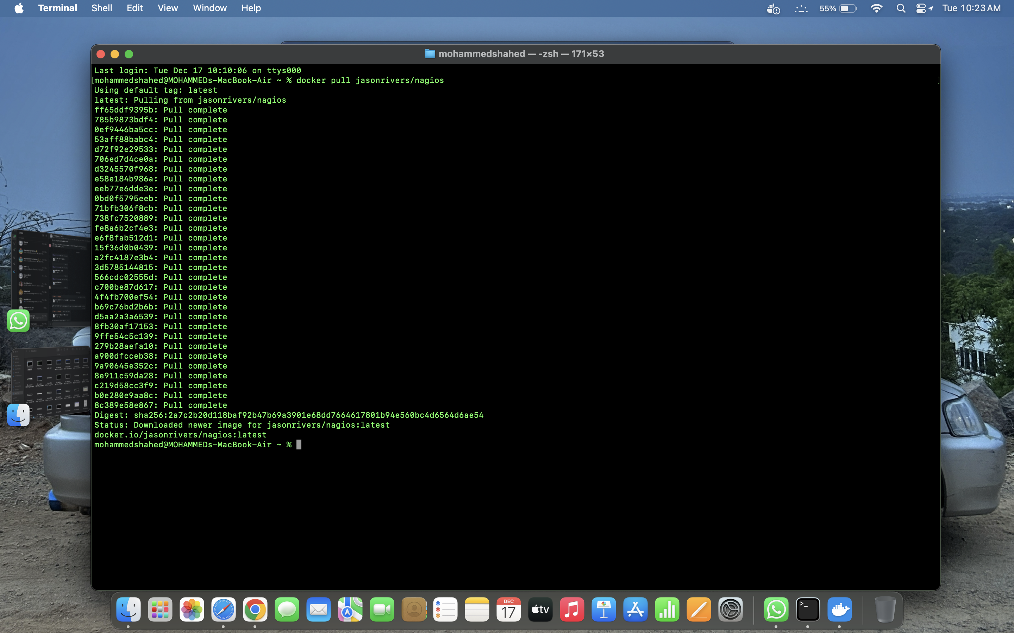

6.Search for localhost with the specified port number i.e, 6069 and specify username as nagiosadmin,password as nagios :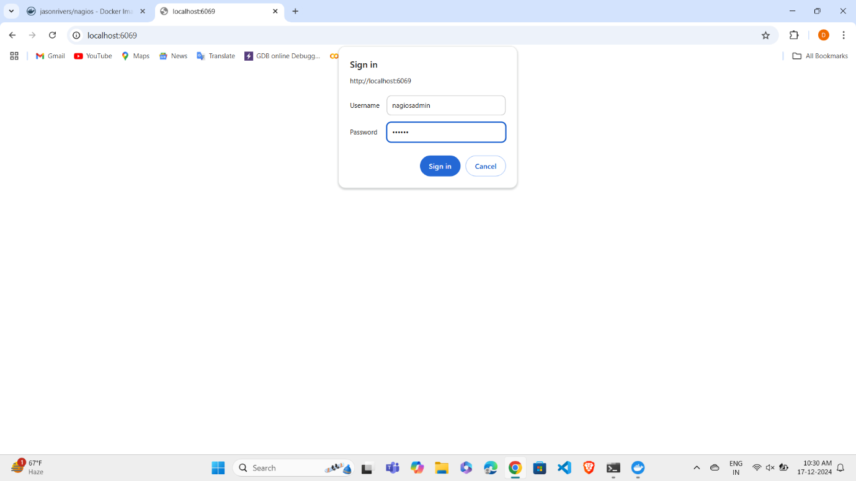

7.Dashboard of Nagios

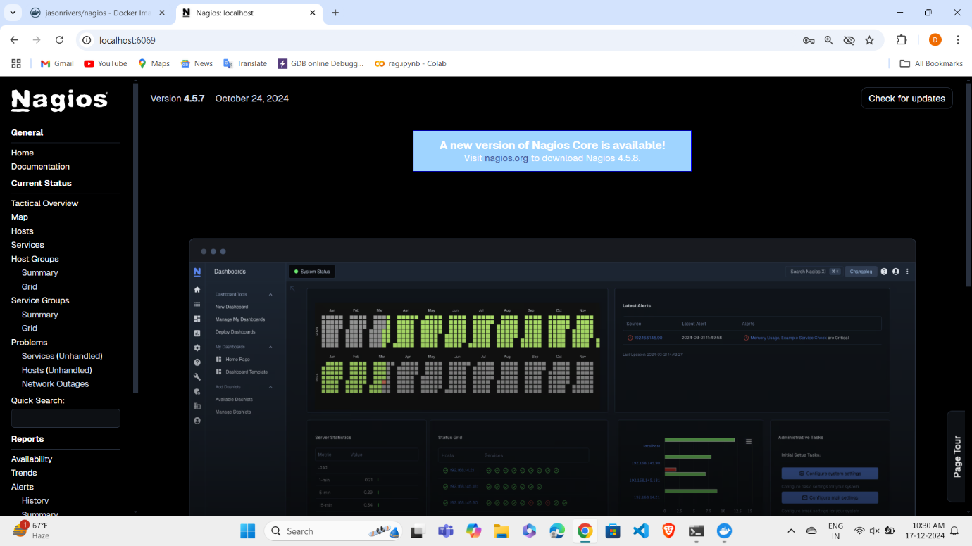

8.Open hosts and checkout for View host status detail for all host groups :